TITANIC DATA SCIENCE PROJECT
NAME: ISAAC KAMAU NDICHU
This project focuses on understanding data analysis, visualization, and machine learning by applying them to a real-world dataset.

Introduction
The titanic dataset is one of the most widely used datasets in data science for learning and practicing machine learning techniques. It contains information about passengers aboard the Titanic, including their age, gender, ticket class, fare, and survival status.
The purpose of this project is to analyze the dataset and build a machine learning model that can predict whether a passenger survived or not. By exploring patterns in the data, the project aims to identify key factors that influence survival during the titanic disaster.
This project demonstrates the complete data cleaning, visualization, feature engineering, model building and evaluation.

Methodology
The project followed a structured data science process to ensure accurate analysis and reliable results.
- Data Collection
The titanic dataset was loaded from a CSV file containing passenger’s details such as age, sex, class, fare, and survival status.

Data Cleaning
Data preprocessing was performed to handle missing and inconsistent values. Missing values in columns such as age were filled using appropriate methods, while unnecessary columns that did not contribute to the analysis were removed.
- Feature Engineering
New features were created to improve model performance. For example, s Family Size feature was derived by combining the number of siblings/spouses and parents/children abroad.
- Data Visualization
To better understand the titanic dataset, several visualization were created using libraries such as Matplotlib and seaborn, to identify patterns and relationship between variables.
Fig 1: Survival Percentage
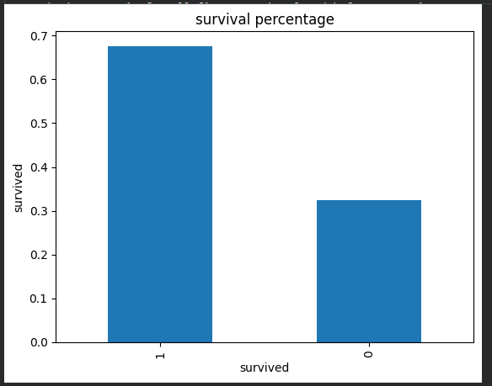
This chart shows the overall proportion of passenger who survived versus those who did not. It indicates that a larger percentage of passengers did not survive, highlighting the severity of the disaster.

Fig 2: Survival

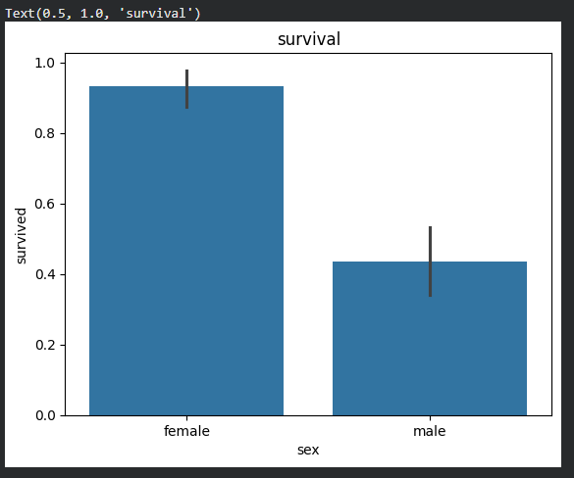
This chart compare the number of male and female survivors. It clearly shows that female survivor were more than male survivor.

Fig 3: Fare Distribution by Class

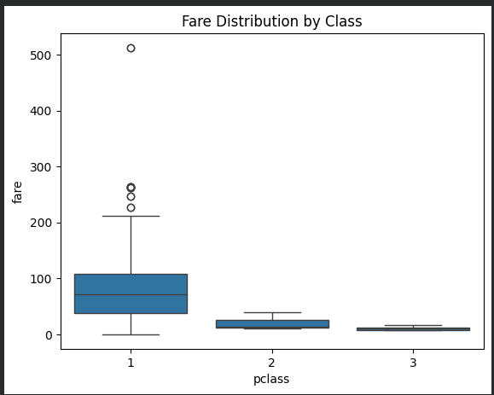
This graph illustrates how ticket fare varied across passenger classes. First-class passengers paid significantly higher fares compared to second and third class, suggesting difference in socioeconomic status among passengers.
Fig 4: Survival Rate by Family Size

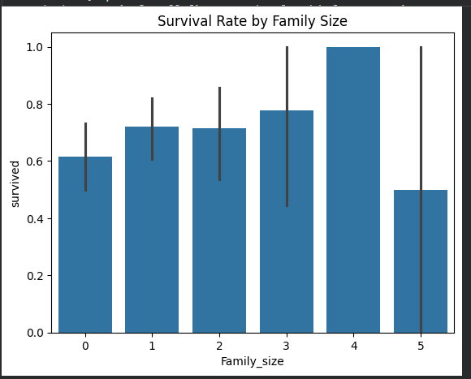
The chart shows how survival varied depending on family size. Passengers travelling in small families had a higher survival rate, while those travelling alone or in very large families had lower chances of survival.
The error bar indicates that the data is unreliable.
Fig 5: Age Distribution
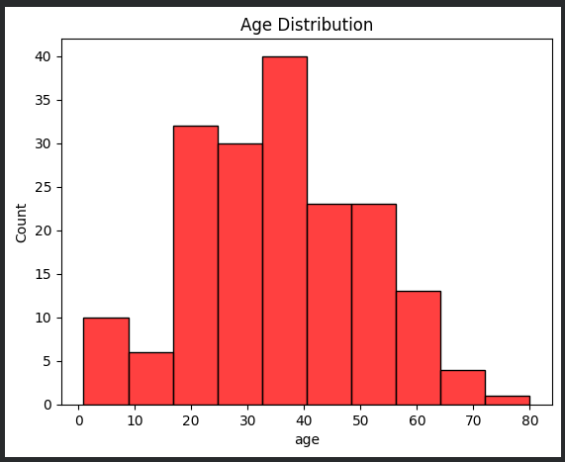
The histogram displays distribution of passenger ages. Most passenger were between 20 and 40 years old, with fewer children and elderly individuals.
Fig 6: Age Distribution by Survival

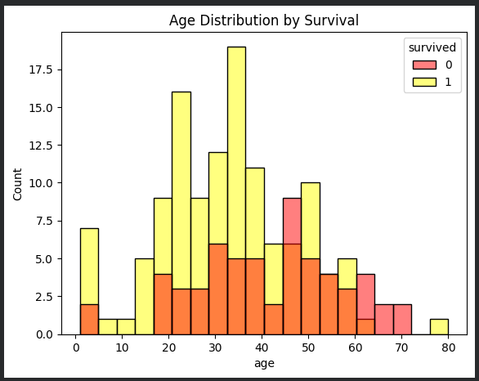
This graph compares the age of survivors and non-survivors. It suggest that younger passengers, especially children, had a slightly higher chance of survival compared to older passengers.
Fig 7: Survival Percentage
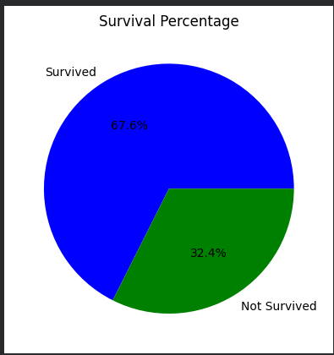
The chart further reinforces the proportion of survivors and non-survivors, emphasizing that survival was less common among passengers.

Fig 8: Age vs. Fare

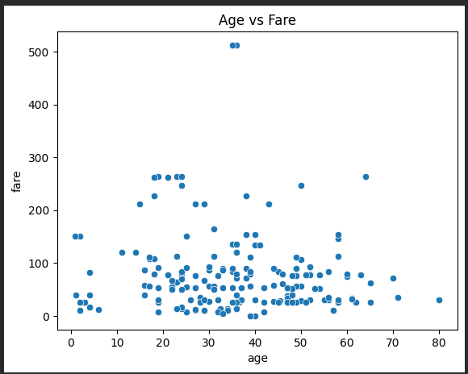
This scatter plot shows the relationship between passenger age and fare paid. There is no strong correlation between age and fare, but higher fare are generally associated with first-class passengers regardless of age.
- Model Building
A logistic Regression model was used to classify whether a passenger survived or not. The model was trained using selected features such as Age, Sex, Passenger Class, Fare, and family Size.
- Model Evaluation
The model performance was evaluated using accuracy and a confusion matrix.
Fig 9: Confusion Matrix

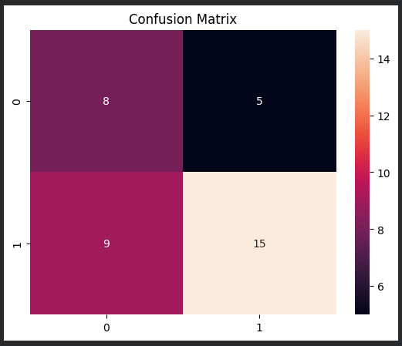
The Confusion Matrix evaluates the performance of the machine learning model. It shows the number of correct and incorrect predictions. Most values lie along the diagonal, indicating that the model correctly predicted a majority of survival outcomes, with relatively few misclassifications.

Conclusion
Data was cleaned and analyzed
Model was trained and tested
Prediction were made successfully.
This completes a data science pipeline.

